**VIETNAM NATIONAL UNIVERSITY HO CHI MINH CITY UNIVERSITY OF SCIENCE**

**FACULTY OF INFORMATION TECHNOLOGY**



**LAB02 REPORT**

**SUBJECT: ARTIFICIAL INTELLIGENCE**

Decision Tree with scikit-learn

**Theory lecturers & instructors:** Mrs. Nguyen Ngoc Thao Mrs. Ho Thi Thanh Tuyen Mr. Nguyen Hai Dang

Mr. Le Ngoc Thanh

**Students:**

Dang Tien Dat 20127458

Table of Contents

**I.** **Preparing the datasets:** 2

II. Building the decision tree classifiers: 2

1. Train/test – 40/60: 2

2. Train/test – 60/40: 3

3. Train/test – 80/20: 4

4. Train/test – 90/10: 5

**III.** **Evaluating the decision tree classifier:** 5

1.Train/test – 60/40: 5

2. Train/test – 40/60: 6

3. Train/test – 80/20: 7

4. Train/test – 90/10: 8

**IV.** **The depth and accuracy of a decision tree:** 9

**V.** **References:** 12

**Note:** *Before we proceed to write the functions to do the below requirements we need to import the necessary libraries (scikit-learn, numpy, matplotlib.pyplot, pandas, seaborn, ...) and data needed (connect-4.data) for this lab .*

*we will compile these libraries using the command:*

**pip install ‘library_you_need’ ex: pip install scikit-learn**

1. **Preparing the datasets:**

Using libraries to split data train_test_split(..,test_size=testSize*0.01, shuffle=True, stratify=y)

# Building the decision tree classifiers:

1. Train/test – 40/60:

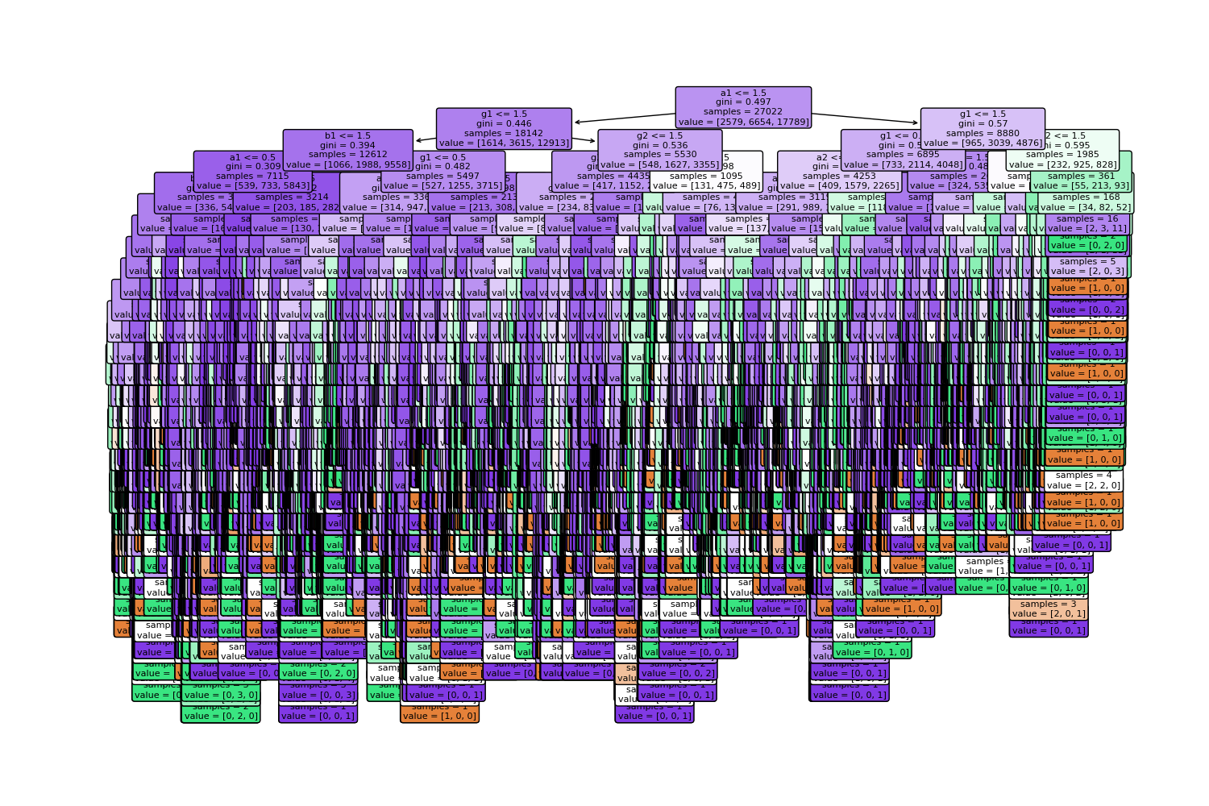

1. Train/test – 60/40:

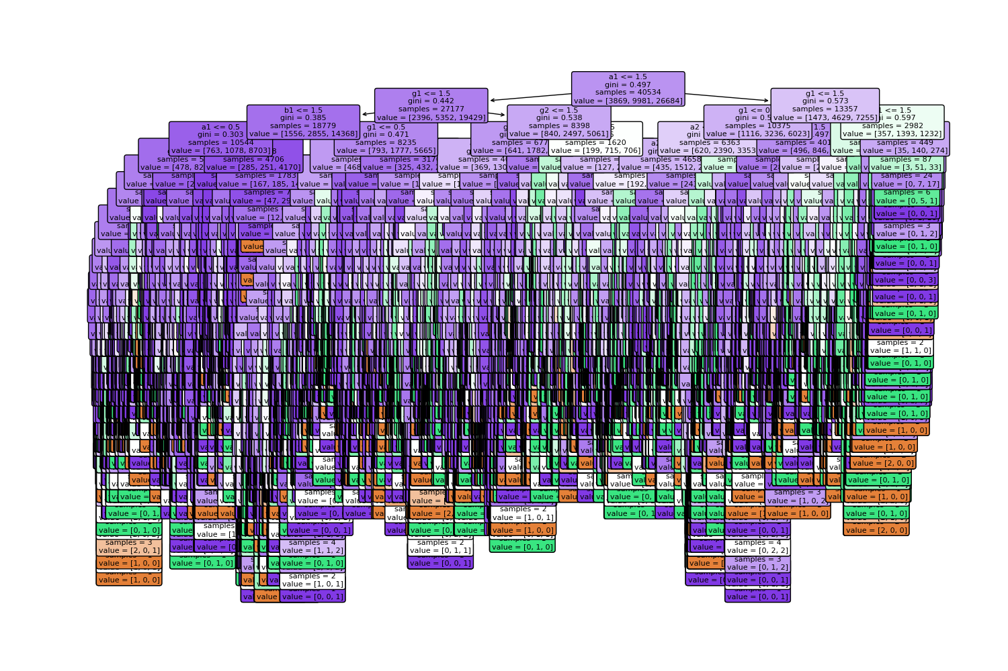

1. Train/test – 80/20:

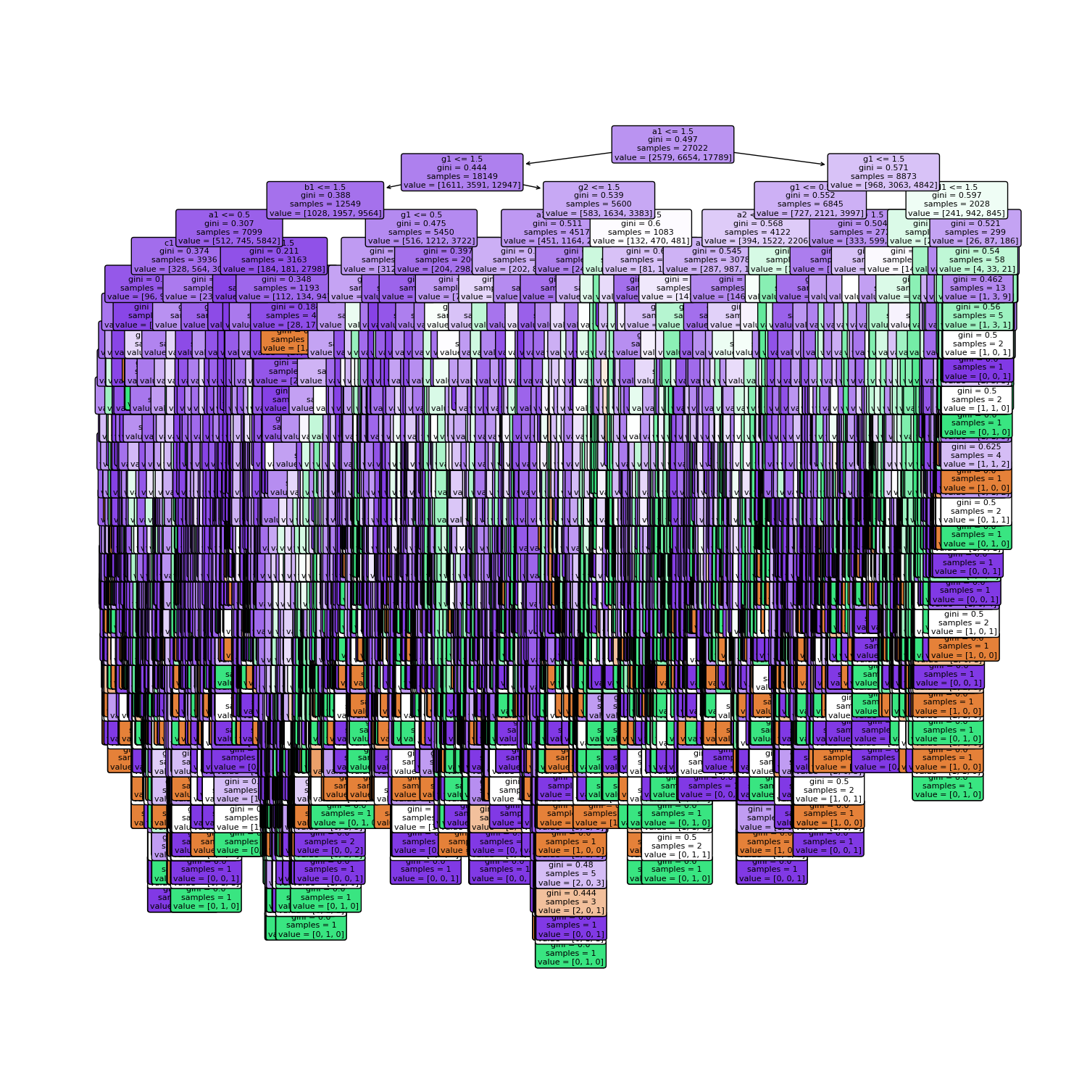

1. Train/test – 90/10:

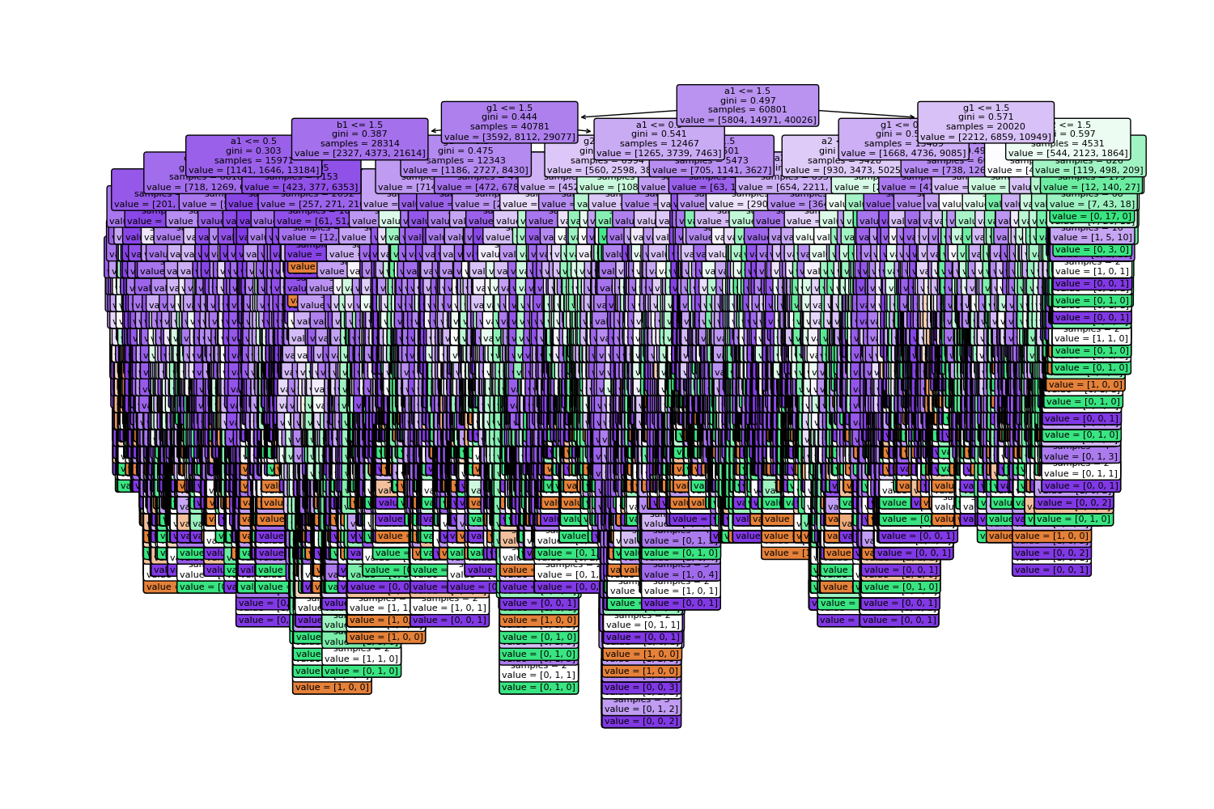

1. **Evaluating the decision tree classifier:**

1.Train/test – 60/40:

* Decision tree classifier report:

* Decision tree classifier confusion matrix:

* Comments on the performances

2. Train/test – 40/60:

* Decision tree classifier report:

* Decision tree classifier confusion matrix:

* Comments on the performances

3. Train/test – 80/20:

* Decision tree classifier report:

* Decision tree classifier confusion matrix:

* Comments on the performances

4. Train/test – 90/10:

* Decision tree classifier report:

* Decision tree classifier confusion matrix:

* Comments on the performances

1. **The depth and accuracy of a decision tree:**

This task works on the 80/20 training set and test set:

* The decision tree for each max_depth:

The max_deapths correspond from left to right and top to bottom, respectively: None, 2, 3, 4, 5, 6, 7

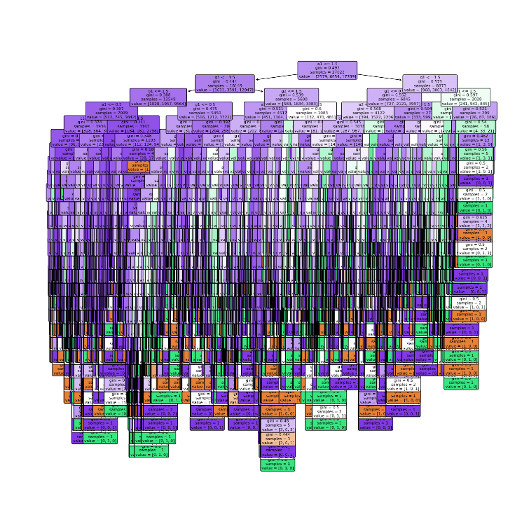

* **Relationship of depth and accuracy by chart:**

* **Relationship of depth and accuracy by table:**

|  |  |  |  |  |  |  |  |
| --- | --- | --- | --- | --- | --- | --- | --- |
| **max_depth** | **None** | **2** | **3** | **4** | **5** | **6** | **7** |
| **Accuracy** | **1.0** | **0.660672** | **0.663558** | **0.674289** | **0.681024** | **0.695752** | **0.70752** |

* **Comment on the above statistics:**
* Accuracy only increases to a limit point and will no longer increase proportionally with max_deapth
* Accuracy increases with the depth of the decision tree classifiers. ( As depth increases, accuracy increases).

1. **References:**
2. [**https://www.kaggle.com/code/haimfeld87/analysis-and-classification-of-mushrooms/notebook**](https://www.kaggle.com/code/haimfeld87/analysis-and-classification-of-mushrooms/notebook)
3. [**https://www.geeksforgeeks.org/graph-plotting-in-python-set-1/**](https://www.geeksforgeeks.org/graph-plotting-in-python-set-1/)
4. [**https://scikit-learn.org/stable/modules/tree.html**](https://scikit-learn.org/stable/modules/tree.html)
5. [**https://scikit-learn.org/stable/modules/generated/sklearn.tree.plot_tree.html**](https://scikit-learn.org/stable/modules/generated/sklearn.tree.plot_tree.html)
6. [**https://scikit-learn.org/stable/modules/generated/sklearn.model_selection.train_test_split.html?fbclid=IwAR0F1PpGJvVxvcb7jLiLbQB9y3GCNZcnsa2TAQUMh3lti6tWyO8IMe9Q9m4**](https://scikit-learn.org/stable/modules/generated/sklearn.model_selection.train_test_split.html?fbclid=IwAR0F1PpGJvVxvcb7jLiLbQB9y3GCNZcnsa2TAQUMh3lti6tWyO8IMe9Q9m4)